Manual GUI Setup Guide
Active Directory Domain Services & DNS — Windows Server 2019
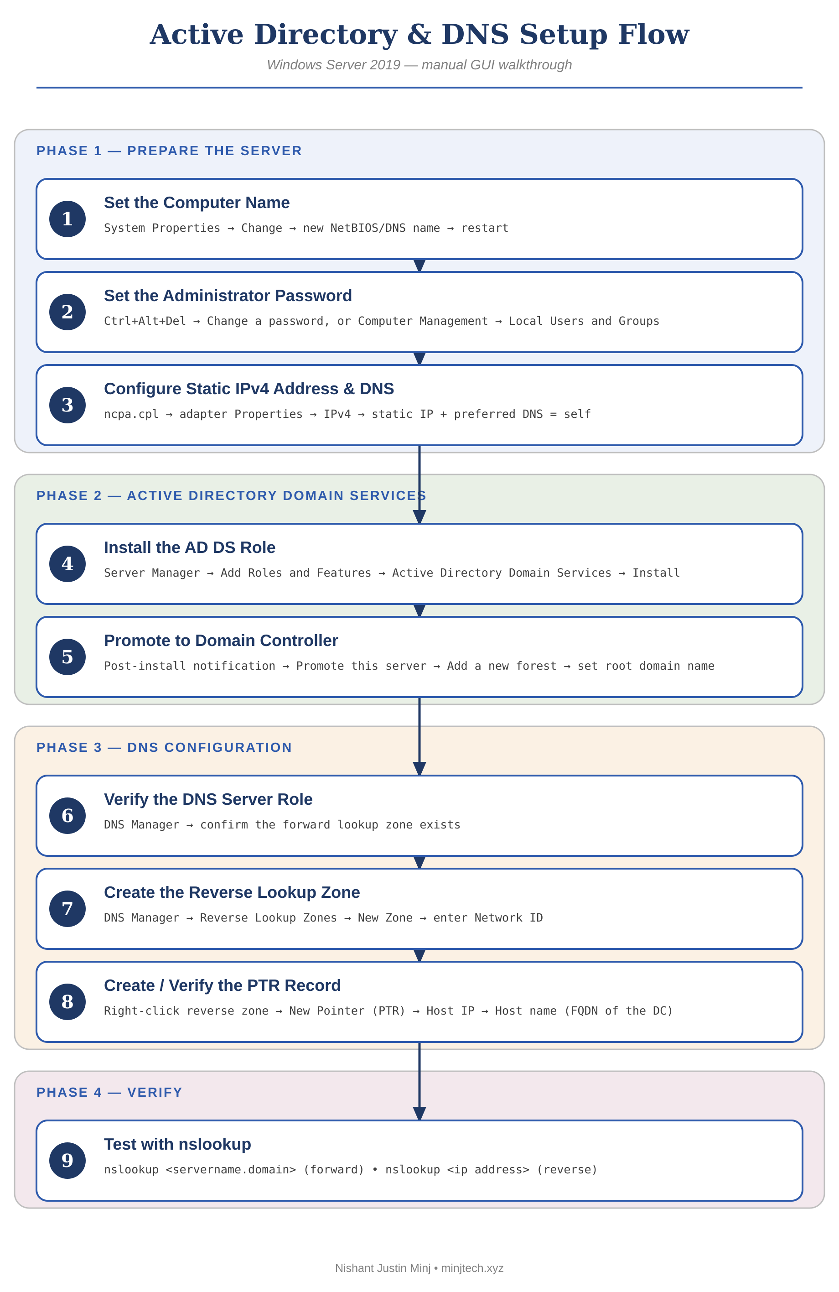

Before You Begin
- Log in to the server console with an account that is a member of the local Administrators group.
- Decide the target computer name, domain name, and NetBIOS name in advance — renaming after promotion is disruptive.
- Have the static IPv4 address, subnet mask, and default gateway ready.
- This guide covers a single, first Domain Controller creating a brand-new forest. Joining an existing domain follows a similar wizard with different choices at Steps 5 and 7.

Phase 1 — Prepare the Server
1 | Set the Computer Name
Rename the server before promoting it to a Domain Controller.
- Press Win + R, type sysdm.cpl, and press Enter.
- On the Computer Name tab, click Change...
- Enter the new computer name (e.g. APP010W001).
- Click OK. Windows confirms a restart is required.
- Click OK, then Close, then Restart Now.
2 | Set the Administrator Password
If you're already signed in as Administrator:
- Press Ctrl + Alt + End (or Ctrl+Alt+Delete on a physical console).
- Select Change a password.
- Enter the current password, then the new password twice, and press Enter.
If the Administrator account is disabled, renamed, or missing (common on cloud-provisioned images):
- Right-click Start → Computer Management.
- Expand System Tools → Local Users and Groups → Users.
- If Administrator exists: right-click it → Set Password... → confirm the warning → enter the new password twice → OK.
- If it's disabled: right-click it → Properties → uncheck "Account is disabled" → OK.
- If it doesn't exist: right-click the Users pane → New User... → set the user name to Administrator and a password → uncheck "User must change password at next logon" → Create.
- Add it to the local admin group: double-click the account → Member Of tab → Add... → type Administrators → Check Names → OK → OK.
3 | Configure a Static IPv4 Address & DNS
The server needs a fixed IP before it can reliably host DNS for itself and other machines.
- Press Win + R, type ncpa.cpl, and press Enter.
- Right-click the active network adapter → Properties.
- Select Internet Protocol Version 4 (TCP/IPv4) → Properties.
- Select "Use the following IP address" and enter the IP address, subnet mask, and default gateway.
- Select "Use the following DNS server addresses." Set Preferred DNS server to this server's own static IP — it will be hosting DNS itself once AD DS is installed.
- Click OK, then Close.
- Open Command Prompt and run ipconfig /all to confirm the settings took effect.

Phase 2 — Active Directory Domain Services
4 | Install the AD DS Role
- Open Server Manager → Dashboard → Add roles and features.
- Before You Begin: click Next.
- Installation Type: choose "Role-based or feature-based installation" → Next.
- Server Selection: confirm the local server is selected → Next.
- Server Roles: check Active Directory Domain Services. When prompted to add required features, click Add Features → Next.
- Features: leave the defaults → Next.
- AD DS: read the informational page → Next.
- Confirmation: optionally check "Restart the destination server automatically if required" → click Install.
- Wait for the installation to finish, then click Close.
5 | Promote the Server to a Domain Controller
- In Server Manager, click the yellow notification flag (top right) → "Promote this server to a domain controller."
- Deployment Configuration: select "Add a new forest" and enter the root domain name (e.g. minjtech.xyz) → Next.
- Domain Controller Options: choose the forest and domain functional levels, confirm "Domain Name System (DNS) server" is checked, and set a Directory Services Restore Mode (DSRM) password → Next.
- DNS Options: a warning about DNS delegation is expected on the first DC in a new forest and can be ignored → Next.
- Additional Options: confirm the auto-generated NetBIOS domain name (e.g. MINJTECH) → Next.
- Paths: accept the default AD DS database, log file, and SYSVOL locations, or customize them → Next.
- Review Options: confirm the summary → Next.
- Prerequisites Check: wait for checks to complete (warnings are typically fine; errors must be resolved first) → click Install.
- The server reboots automatically once promotion completes.

Phase 3 — DNS Configuration
6 | Verify the DNS Server Role
Promotion installs and configures the DNS Server role automatically — this step just confirms it.
- Log back in using the domain Administrator account (DOMAIN\Administrator).
- Open Server Manager → Tools → DNS (or press Win+R and run dnsmgmt.msc).
- Expand the server node → Forward Lookup Zones and confirm a zone matching your domain exists, with an A record for the DC.
7 | Create the Reverse Lookup Zone
Reverse zones are not created automatically — this has to be done manually (or scripted).
- In DNS Manager, right-click Reverse Lookup Zones → New Zone...
- New Zone Wizard: click Next.
- Zone Type: select Primary zone, and confirm "Store the zone in Active Directory" is checked → Next.
- Active Directory Zone Replication Scope: choose "To all DNS servers running on domain controllers in this forest" (or as appropriate for your environment) → Next.
- Reverse Lookup Zone Name: select IPv4 Reverse Lookup Zone → Next.
- Enter the Network ID (e.g. 172.16.0 for a /24 network). Windows generates the zone name automatically (e.g. 0.16.172.in-addr.arpa) → Next.
- Dynamic Update: select "Allow only secure dynamic updates" for an AD-integrated zone → Next.
- Click Finish.
8 | Create or Verify the PTR Record
- In DNS Manager, expand Reverse Lookup Zones and select the new zone.
- Check whether a Pointer (PTR) record already exists for the DC's IP — dynamic registration sometimes creates it automatically within a few minutes.
- If it's missing, right-click the zone → New Pointer (PTR)...
- Host IP number: enter the last octet(s) of the DC's IP address.
- Host name: click Browse... and select the DC's A record, or type its FQDN directly (e.g. app010w001.minjtech.xyz.).
- Click OK.

Phase 4 — Verify
9 | Test with nslookup
- Open Command Prompt.
- Forward lookup — run: nslookup app010w001.minjtech.xyz — it should return the server's IP address.
- Reverse lookup — run: nslookup <the IP address> — it should return the server's FQDN.
- If either fails, run ipconfig /flushdns and retry, then re-check the corresponding record in DNS Manager.

Notes
This manual walkthrough matches the automated Setup-ADDS-DNS.ps1 script step-for-step. The script exists to do exactly the above unattended and to survive the reboots at Steps 1 and 5 automatically — use whichever fits the situation.

